

*Project Plan*

Course: Project Management



May 11, 2020

Submitted to: **Ms. Ridah Fatima**

By:

* **Naeem Ali – 13292**
* **M. iftikhar Uddin Khan Sami - 13275**

Contents

Draft a document that defines the following aspects of the given E – Commerce website: 2

The Program is an E – commerce website, identify the sub projects in it. 2

Draw a diagram that shows the relationship between different sub projects and highlights individual projects. (you may use Figure 1.1 template) 2

Identify the stakeholders and their types. 2

Define the Program scope and the project(s) scope. 3

Identify which strategic considerations are fulfilled through the project and how. (1.4.3) 3

Identify the requirements. 3

While identifying the requirements think of features you will suggest to add in order to enhance the requirement. 3

Identify the Project Life Cycle that you think best suits the requirements. 4

Based on the Project Life Cycle choose a Software Development Life Cycle. 4

Perform Requirement Engineering on the collected requirements. 4

Write story cards to explain the requirements at its best. 5

FDD : 9

Gantt chart: 11

Task’s List: 11

Project Timeline: 12

Resource Sheet: 12

Tasks – For Network Diagram and Pert Chart: 13

Network Diagram: 13

Pert Chart: 14

Risk Register: 14

**Complete Submissions Link:** [**Project Management Submissions- Google Drive folder**](https://drive.google.com/open?id=16xc_gLvDfksaPJEWQoXid-STswi0czH1)

# Draft a document that defines the following aspects of the given E – Commerce website:

## The Program is an E – commerce website, identify the sub projects in it.

Our e-commerce website is for selling cloths online. User can buy clothes from our website by searching as per his desire, demand and budget. **ClothesOnline.com** is our e-commerce website brand that deal with the whole cycle involving from the arrival of user on Website till the ending of sessions.

Sub-projects for our e-commerce website:

* Login
* Signup
* Add to cart
* PayPal
* Card Payment
* COD
* Newsletter
* Wishlist

## Draw a diagram that shows the relationship between different sub projects and highlights individual projects. (you may use Figure 1.1 template)

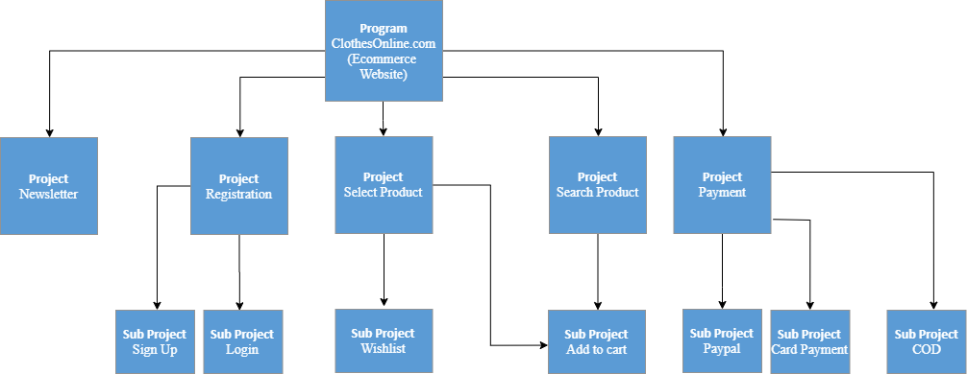

## Identify the stakeholders and their types.

The Stakeholders for our brand **ClothesOnline.com** are as follows:

1. Vendors - Sellers
2. Buyers - End-user
3. Payment partners - Business partner
4. Shipping partners - Business partner
5. Designers - Organizational partners
6. Web developers - Organizational partner
7. System owner - Sponsors
8. Social media - Business partners

## Define the Program scope and the project(s) scope.

* A platform from where the goods can be bought and sold easily by paying online or on your doorstep
* A platform which can be competitive and easy to use as compared to other available E-commerce websites

## Identify which strategic considerations are fulfilled through the project and how. (1.4.3)

* **Market demand:** On their smartphone People want to be able to browse the internet and access the information they need from their favorite devices without any headaches or second-guessing.
* **Customer request:** Making your online store layout intuitive for the visitor is a valuable way to draw their attention to the right places. For instance, organizing your products into logical categories and sub-categories, and making sure those categories are highly visible, will help shoppers quickly find the products that interest them most.
* **Technological advance:** Online shoppers want convenience, and they won’t stick around if a page takes forever to load. The online shopping experience should be seamless and easy, especially since 40% of people will abandon a website that takes more than three seconds to load. In fact, a one second delay in page response can lead to a 7%decrease in conversions. Website convert to mobile application; we use high quality images and payment method.

## Identify the requirements.

## While identifying the requirements think of features you will suggest to add in order to enhance the requirement.

|  |  |
| --- | --- |
| **Functional** | **Non-Functional** |
| Search | Performance |
| Add to cart | Efficiency |
| Product Images | Usability |
| Individual product page | Security |
| Reviews | Stability |
| Sign in/out | Transparency |
| Payment | Compatibility |
| Wish-list | Scalability |
| Social media icons | High Quality image |
| Discounts |  |
| Checkout |  |
| Progress bar |  |

## Identify the Project Life Cycle that you think best suits the requirements.

**Iteration and incremental life cycle** - is best suit for that project as well as for program and for sub programs. Because in that life cycle we will make sure the scope, cost and objective step by step easily.

## Based on the Project Life Cycle choose a Software Development Life Cycle.

**Prototype (Iterative SDLC) methodology** because we can use prototyping to ensure customer satisfaction. It is an ecommerce website which will need lots of modifications according to owner’s perspective. For this reason, Prototyping SDLC methodology is best suited for our program.

## Perform Requirement Engineering on the collected requirements.

* Items can be added to cart.
* Products details can be shown to individual pages.
* Registration process for user.
* Payment gateway in website to ensure customer satisfaction or COD option.
* User can search for products from search bar by name.
* Image of product needs to be of good quality. So, if zoom into picture it shouldn’t pixelated.
* User can give his review about the product.
* Wish list for users to add products into wish list for later purchasing.
* Discount vouchers for user.
* Social media icons in website.
* Checkout page will need user data to process checkout. E.g. User details, card details.

## Write story cards to explain the requirements at its best.

**New User**

**As a:**

Guest

**I can:**

View products and see details of a specific product.

**Work:**

Products will be available to guest. Guest can see product description, reviews, and can add product to cart but needs to sign in before checkout.

**Registration**

**As a:**

New User

**I can:**

Signup for an account.

**Work:**

User will need to enter details to sign up like First Name, Last Name, Phone, Email, Password.

Data will be saved into database in tblUsers table.

Successful registration will redirect to login screen.

**Login**

**As a:**

Registered user

**I can:**

Sign in to account.

Maintain profile.

View products.

Product description.

Add products to cart.

View Cart.

Move to checkout page.

**Work:**

If the user has provided valid credentials, the details will be validated from database from tblUsers.

If validated screen will be redirected dashboard.

**Products**

**As a:**

User

**I can:**

View product description.

View product ratings.

Add product to cart.

**Work:**

Selected product will be shown into new page.

Product details will be fetched from database from tblProducts.

Products page will show product description, reviews, price.

**Search**

**As a:**

Guest or Registered user

**I can:**

Search for different products.

**Work:**

Search queries will be matched from database from tblProducts.

If product is available, show to user. Else show related products.

**Cart**

**As a:**

User

**I can:**

View my cart page.

Total amount.

Increase quantity in cart.

Move to checkout.

**Work:**

Cart products will be saved in list with product name, quantity, price.

Products details will be fetched from database from tblProducts.

.

**Checkout**

**As a:**

User

**I can:**

Process my checkout.

**Work:**

If user in logged in show to checkout page. Else redirect to sign in page.

Checkout will require user details.

Option will be shown to user for Online payment or COD.

Checkout details will be saved into database in tblOrders.

**Wish list**

**As a:**

User

**I can:**

Add products to wish list.

Access my wish list.

**Work:**

If user is logged in, wish list products will be shown to user. Else user will be redirected to sign in page.

Wish list will be maintained into list.

**Social Media**

**As a:**

User

**I can:**

Access website social media

**Work:**

Social media icons will be available in website. Linked with website social media pages.

**Newsletter**

**As a:**

User

**I can:**

Subscribe to newsletter to be updated for new promotions or deals.

**Work:**

Newsletter subscription box will be available to user. If they want to be notified whenever new promotion or deal is available.

**logout**

**As a:**

User

**I can:**

Checkout from my account.

**Work:**

Users can logout via logout button.

User will be redirected to dashboard. User will need to login again to access account.

**Admin Panel**

**As an:**

Admin

**I can:**

Access admin panel.

**Work:**

Admin can access admin panel with valid credentials.

Credentials will be match with database data from tblAdmin.

If credentials are correct, admin will be redirected to admin panel, else show error for invalid credentials.

**Manage Products**

**As an:**

Admin

**I can:**

Add new products.

Delete products.

Update products.

**Work:**

After valid credentials, admin can add new products to tblProducts with product name, description, image, price.

Admin can delete products from tblProducts.

Admin can update product details in tblProducts.

**Online Payment**

**As an:**

User

**I can:**

Pay amount for my cart via Online.

**Work:**

User can pay their amount online via different payment methods.

In orders table tblOrders, payment will be shown completed.

**Offline Payment**

**As an:**

User

**I can:**

Pay amount for my cart via COD.

**Work:**

User can pay their amount by selecting COD.

In orders table tblOrders, payment will be shown COD.

**New Orders**

**As an:**

Admin

**I can:**

See new orders.

Mark orders complete.

**Work:**

Admin can view new orders from admin panel.

Orders will be loaded from tblOrders table.

Admin can mark orders completed. Completed orders will be marked complete in database table tblOrders.

**Logout**

**As an:**

Admin

**I can:**

Logout from my account.

**Work:**

Admin can logout via logout button.

Admin will be redirected to admin login page.

# FDD :

Link: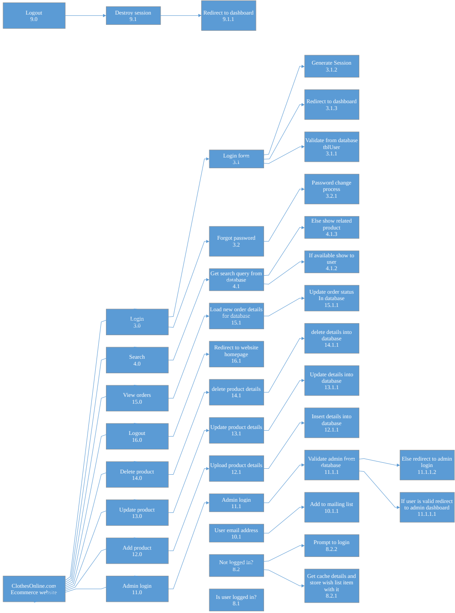 <https://drive.google.com/open?id=19jS4KEhmjeOrjmrdGeMVFhrnH9pEQqfU>

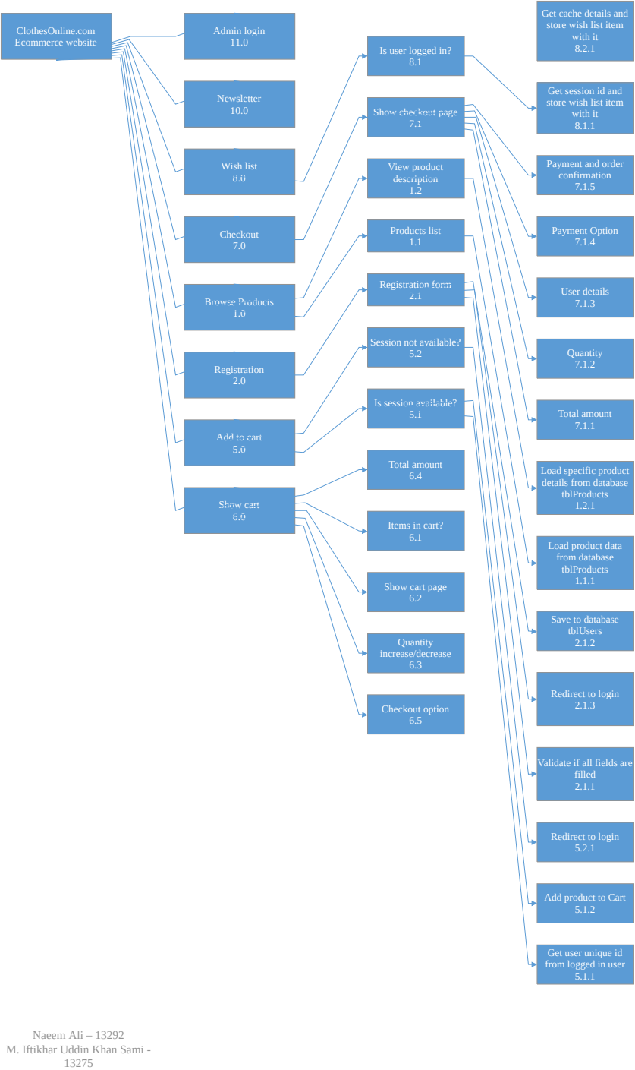

# Gantt chart:

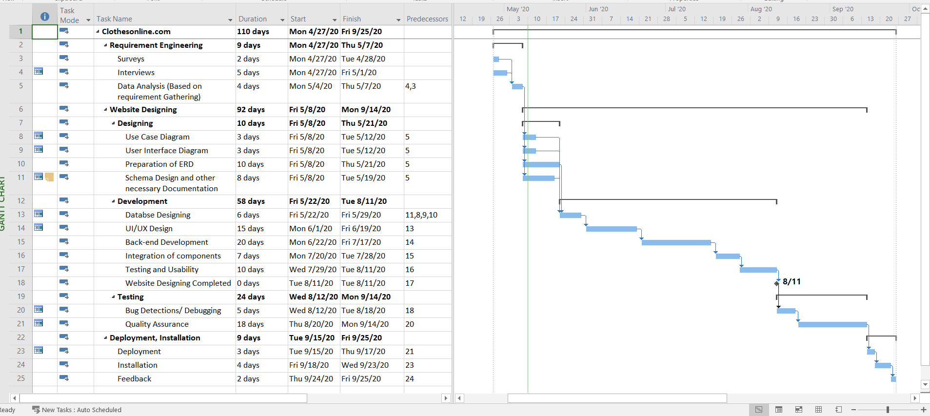

# Task’s List:

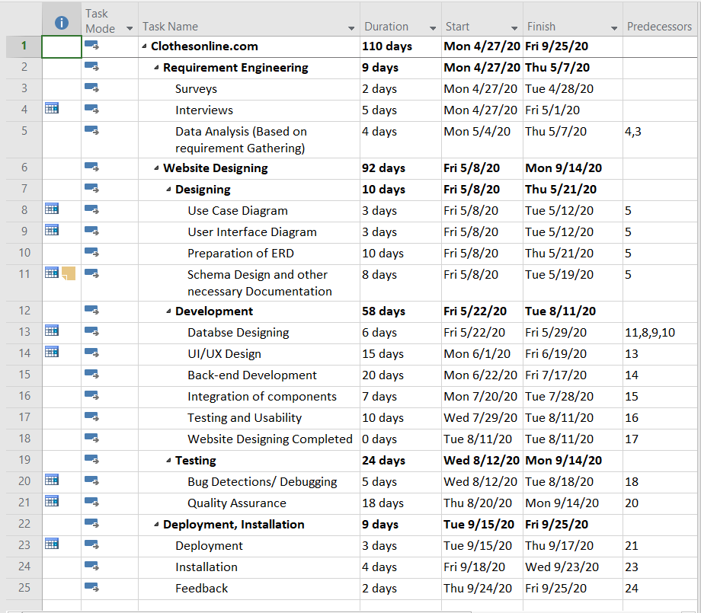

# Project Timeline:

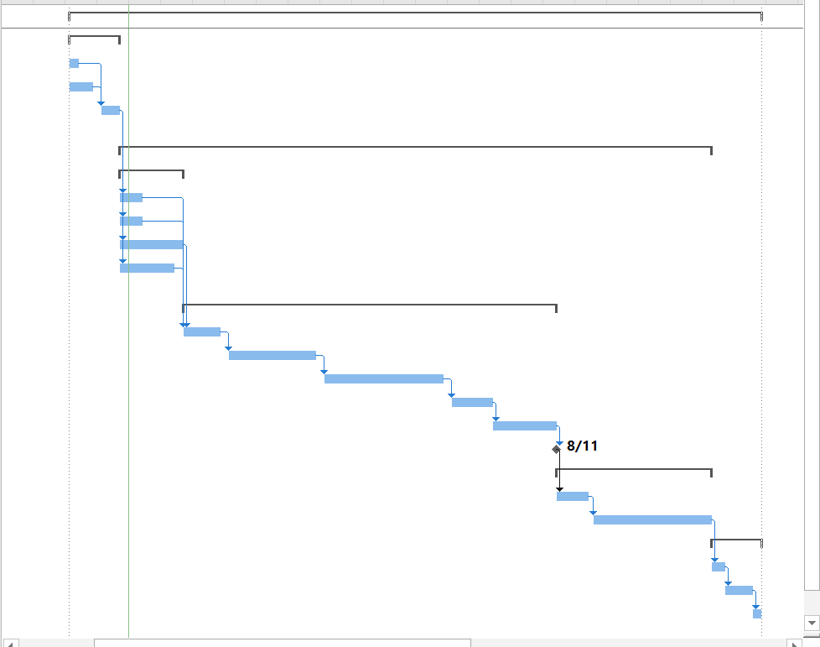

# Resource Sheet:

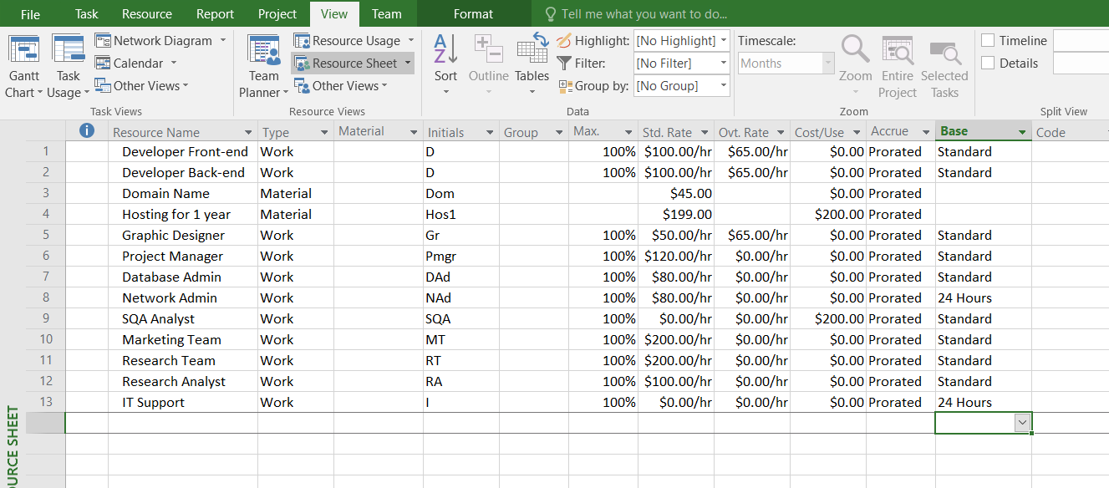

Link: <https://drive.google.com/open?id=15Cjsv8zo4rMqMxXlEHp2TcJHnmfHI-gg>

Link- MS PROJECT File: <https://drive.google.com/open?id=1zj-hAPnOBztwBCFsAj-Ess5hFcxkDkXH>

# Tasks – For Network Diagram and Pert Chart:

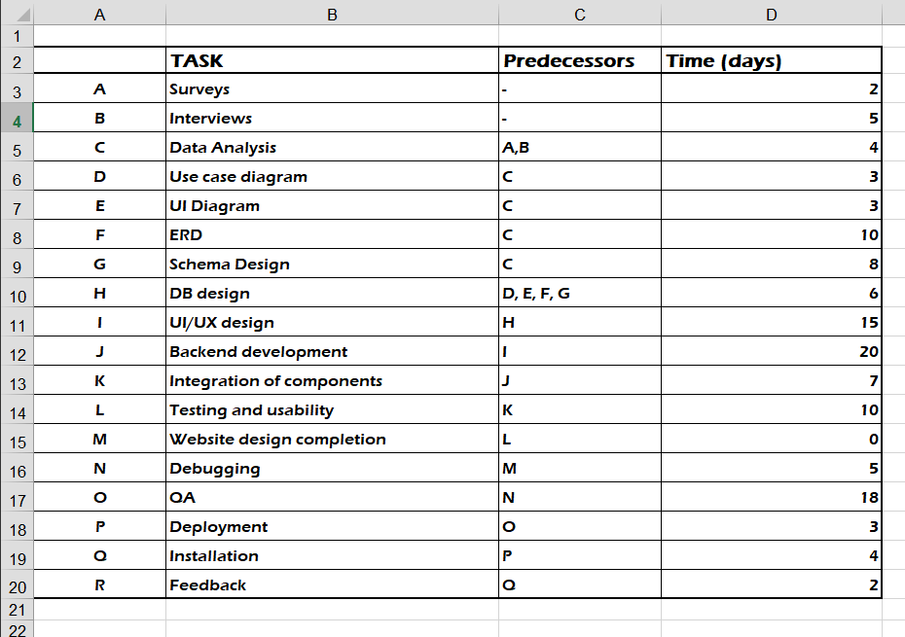

# Network Diagram:

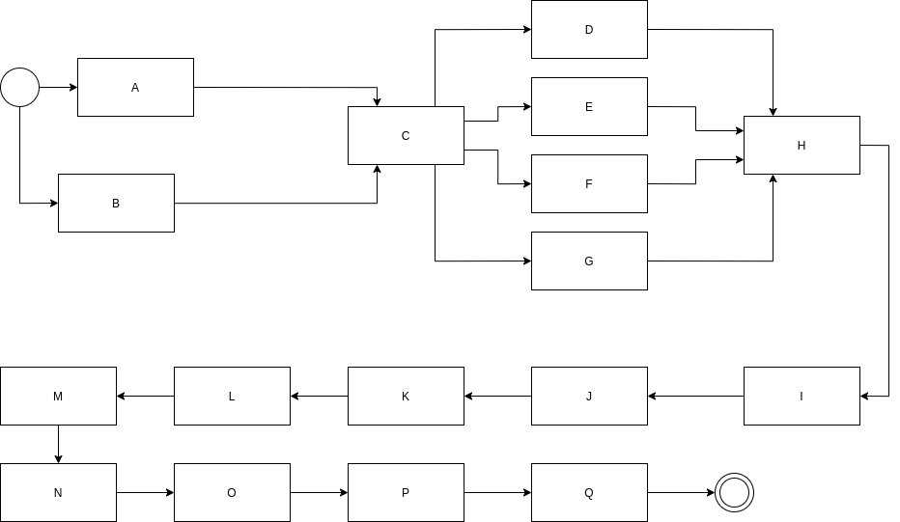

# Pert Chart:

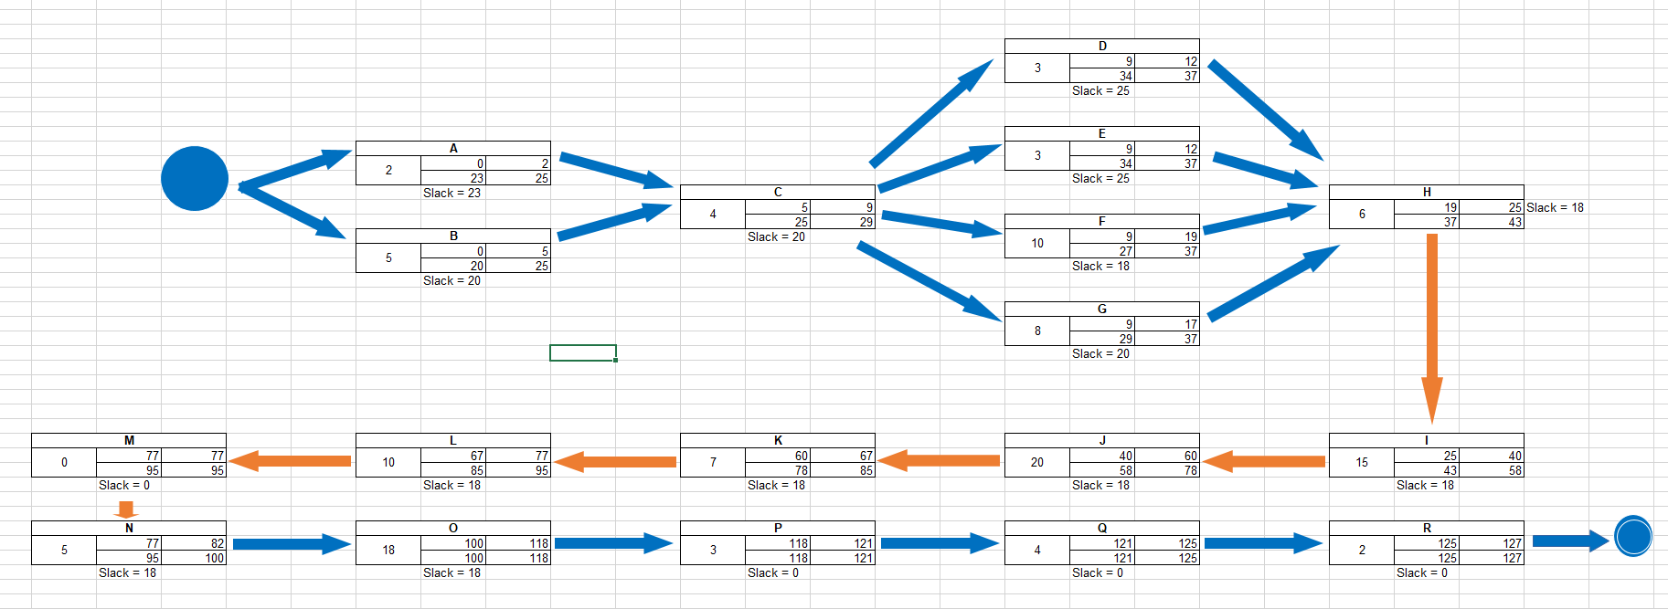

Link: <https://drive.google.com/open?id=1Zn2gG4X6q5_-ejcvLyyMI4N8vmX18liZ>

# Risk Register:

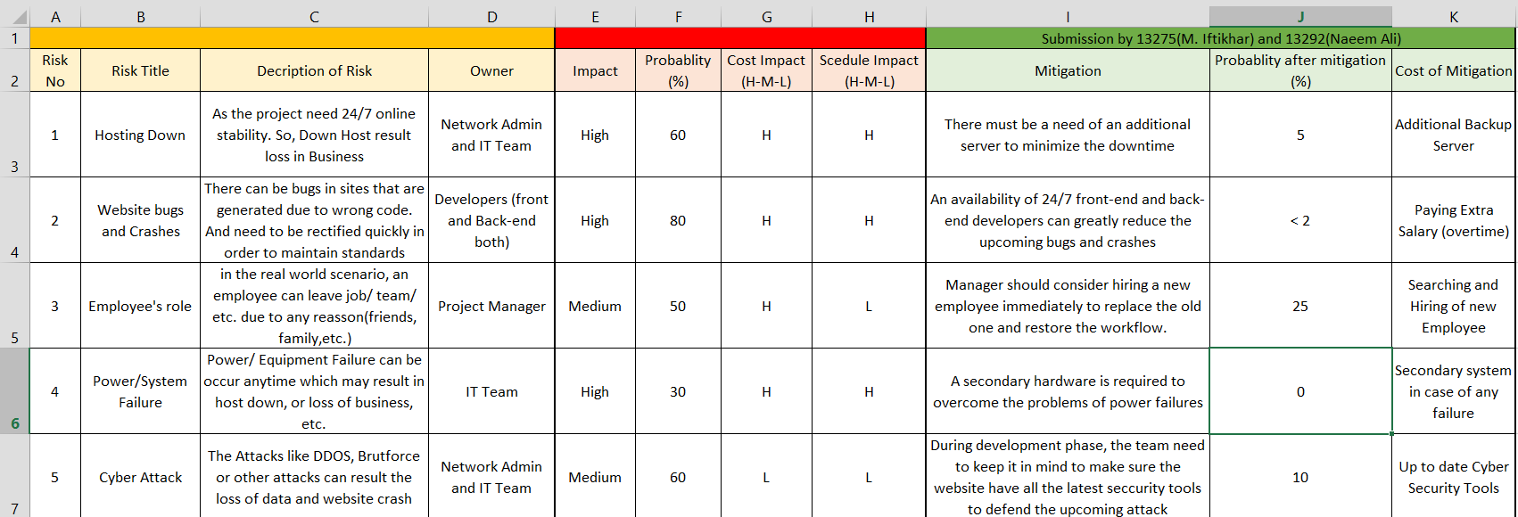

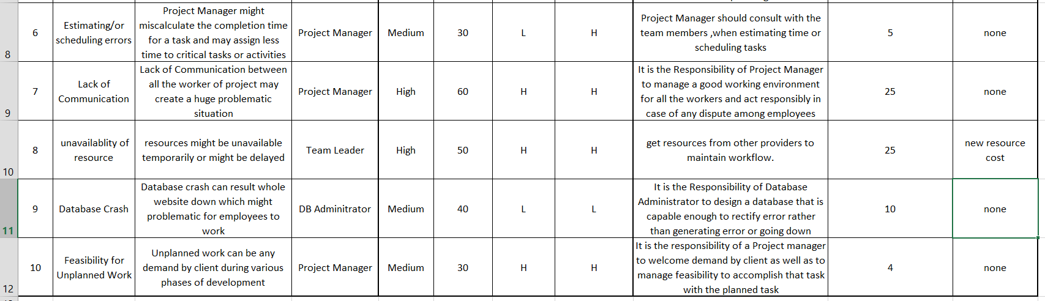

Link: <https://drive.google.com/open?id=1UdFGzuFp9CKMsfsYpnmgJNOIQ37AgeHZ>